**Creative Activity**

Go with an adult and see what bits and bobs you can find in the shed, garage, recycling box, junk draw or garden.

This is what I found in my kitchen junk draw.

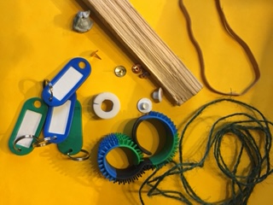

Create whatever you like, maybe an animal, a person or an imaginary object. Try and join materials using different methods. The finished product can be whatever size you like. Remember to use things like scissors, glue guns etc under adult supervision.

Take a photograph and pop it in your home-school book. Here is one I made earlier. It’s a croc-a-meleon called Bob.

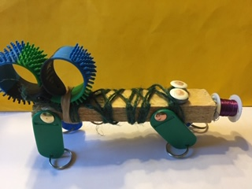

There is more inspiration on the next page…

I’ve named mine Bob the croc-a-meleon. There is some more inspiration below.

Have fun.

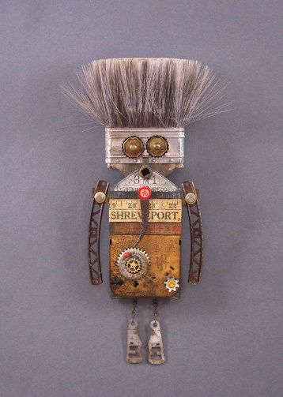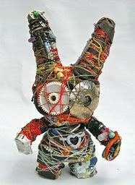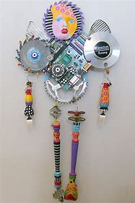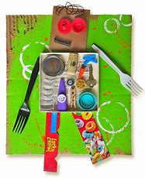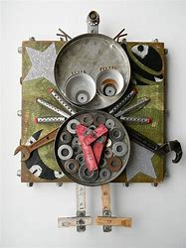Have fun,

I can’t wait to see your creations.