**Year 1 Weight Challenge Activities.**

**1.**

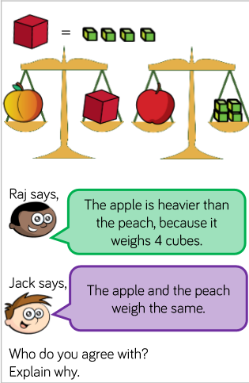

**2.**

