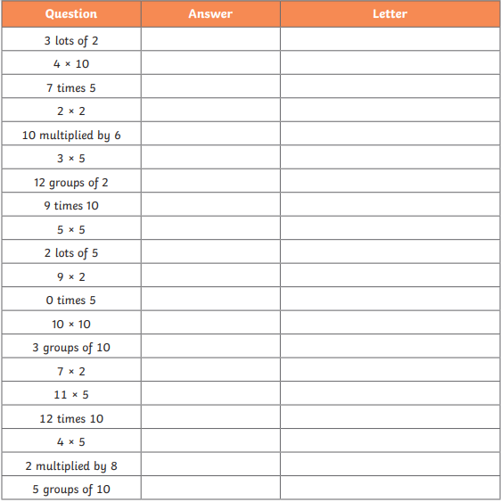
Work out the calculations and write down the answers. Go and find the hidden cards to match the answers and write down the letter. The letters will reveal a phrase. Tomorrow I will tell you the hidden phrase.

