A Series of Unfortunate Events- Book 2
The Reptile Room-
By Lemony Snicket
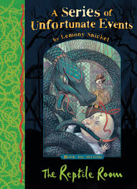

Dear Reader,
If you have picked up this book with the hope of finding a simple and cheery tale, I'm afraid you have picked up the wrong book altogether. The story may seem cheery at first, when the Baudelaire children spend time in the company of some interesting reptiles and a giddy uncle, but don't be fooled. If you know anything at all about the unlucky Baudelaire children, you already know that even pleasant events lead down the same road to misery.
In fact, within the pages you now hold in your hands, the three siblings endure a car accident, a terrible odour, a deadly serpent, a long knife, a large brass reading lamp, and the appearance of a person they'd hoped never to see again.
I am bound to record these tragic events, but you are free to put this book back on the shelf and seek something lighter.
With all due respect,
Lemony Snicket

Florence Nightingale and the Mischievous Kitten-
By Megan Rix
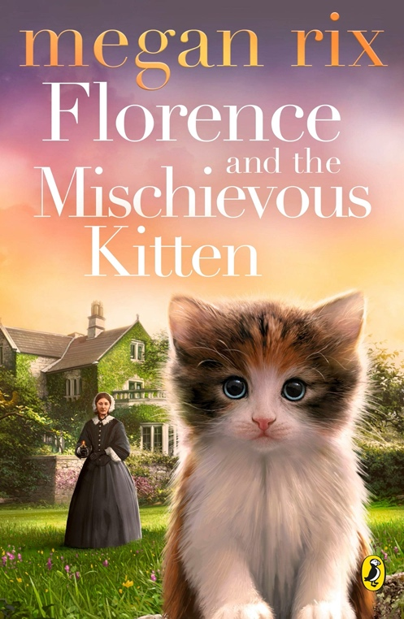

The brilliant new book from Megan Rix, telling the story of Florence Nightingale through the eyes of her young ward. Florence loved cats, and had many during her lifetime. This is the perfect introduction to the Lady with the Lamp for young children, told with warmth, humour and adorable animals.
Summer 1888: In a fancy house in London, a kitten called Scamp escapes through an open window and finds himself lost in the middle of the city. Across Hyde Park, a young girl called Beth is marching with thousands of other girls to protest the working conditions in the Bryant and May match factories.
When Beth stumbles across the tiny kitten she finds that he belongs to none other than Miss Florence Nightingale, who is now indebted to Beth for returning her beloved pet. So begins an unlikely friendship between the great lady, her mischievous kitten, and Beth the penniless orphan.
But when Beth's sister Iris is struck down with illness in one of the poorest parts of London, can Beth, Scamp and Miss Nightingale find a way to save her before it's too late?

The Super Miraculous Journey of Freddie Yates
By Jenny Pearson and illustrated by Rob Biddulph
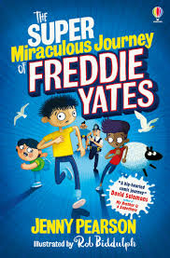

Freddie Yates likes facts. Just not the one staring him in the face – that his secret plan is not, in fact, secret.
Because Freddie's journey wasn't meant to involve Big Trev and the onion-eating competition or the loo-exploding pear-and-potato turnovers. And Freddie definitely didn't expect to end up, with his two best friends, on national television in a super-girl costume.
But journeys never take you where you think they will. And for Freddie, that fact might just have to be enough...

The Last Zoo
By Sam Gayton
Pia lives on the last zoo: a floating armada that houses the strangest collection of creatures the world’s ever seen, from genies to mirror-orangutans to hummingdragons. Collectively called ‘voilas’, they each have a special ability, and everyone hopes these will help save the world from environmental catastrophe.
Pia looks after the angels, their greatest hope. Then one morning they vanish. Panicked, she desperately searches the zoo for any sign of them – but finds something else altogether. An invisible creature is stalking the zoo, sinister forces are at work, and Pia and her friends must find a way to stop it before everything falls apart.
The Last Zoo is a first-class novel with exceptional world-building. An adventure-quest with lightly fantastical elements, it’s fast-paced, has lots of humour and a wonderful range of characters. A brilliant book for anyone looking for a new world to get lost in, it has an environmental message and hints of dystopia whilst also being incredibly hopeful.

Slime
By David Walliams
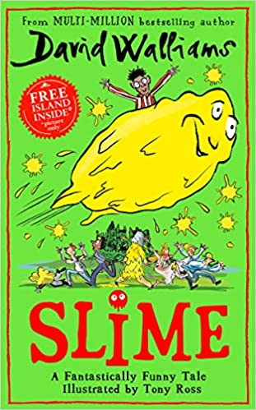
WELCOME TO THE ISLE OF MULCH…
Home to a large number of awful adults who like nothing more than making children miserable. And the island is owned by the most awful one of all – Aunt Greta Greed! Something needs to be done about them. But who could be brave enough? Meet Ned! Ned has lived on Mulch all his life and whilst trying to get his own back on his trickster sister, Jemima, he discovers one of the great mysteries of the world – slime! What is it? Who is it? Where does it come from? And how does Ned use slimepower to take on the horrible grown-ups of Mulch? David Walliams’ legion of fans will delight in an enthralling read that finally unearths the legend of the origins of slime.

David Walliams said: “All children love slime, so I hope they will love this book too. It tells the story of how slime was created, and a boy uses it to wreak revenge on some nasty grown-ups.”

The Further Adventures of the Famous Five
By Enid Blyton
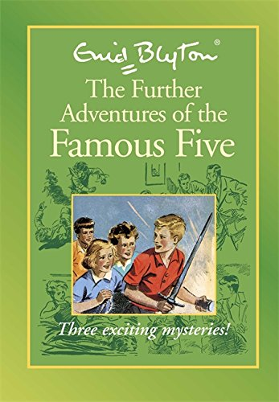

Three Stories in 1 book-

Story 1 : Five Get Into Trouble
Dick's been kidnapped, mistaken for someone else, and the Famous Five are frantic! Desperately, they track him down to a sinister old house in the middle of nowhere - and he's safe and well!
But just when they thought their troubles were over, the gang find themselves held captive and in terrible danger! Who will come for them now...?

Story 2: Five on Finniston Farm

There's a ruined castle on Finniston Farm, but only the dungeons remain - and nobody knows where they are! The Famous Five are determined to find them - and whatever is hidden in them - but they are not alone. Someone else wants to know, too. The question is: can the Five get there first?

Story 3: Five are Together Again
The Famous Five are having great fun camping out near the home of a famous scientist. But they might have known there'd be a mystery to solve. When the scientist's important research papers go missing, he needs the gang's help to get them back! But how can the Five work out who took them? And why?

