This week our art lesson is based on the artist Alberto Giocometti
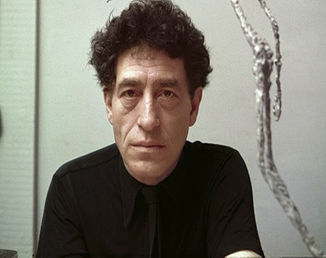
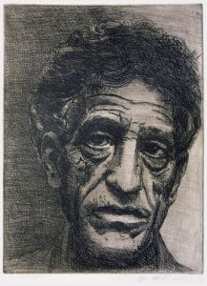
Alberto Giocometti was a swiss artist who explored many art forms throughout his life. He lived from 1901-1966

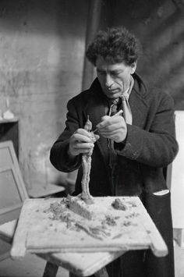
His sculptures were some of his most famous pieces of Art.

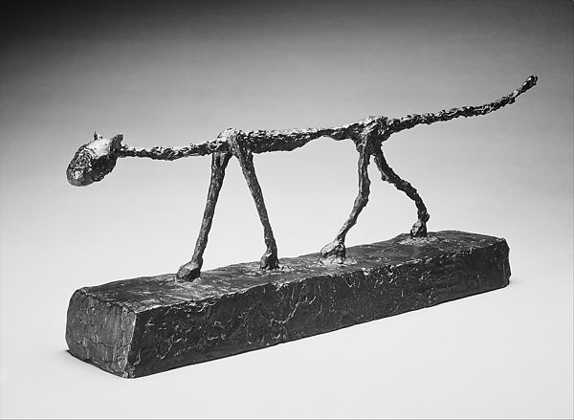
Here are some photographs of his sculptures.

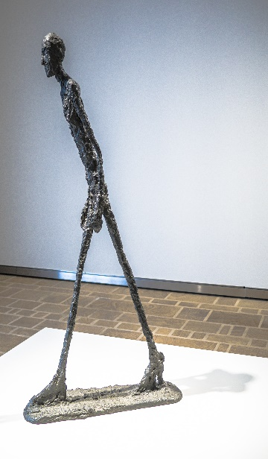
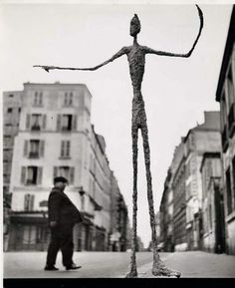

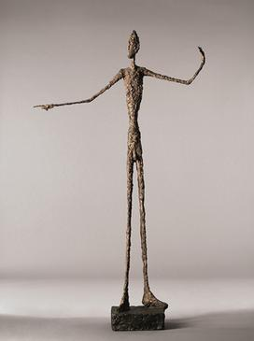

I would like you to build on the skills you were developing in last week’s lesson on figure drawing. Continue to think about the size and proportions of the human body and have a go at sculpting some figures with foil.

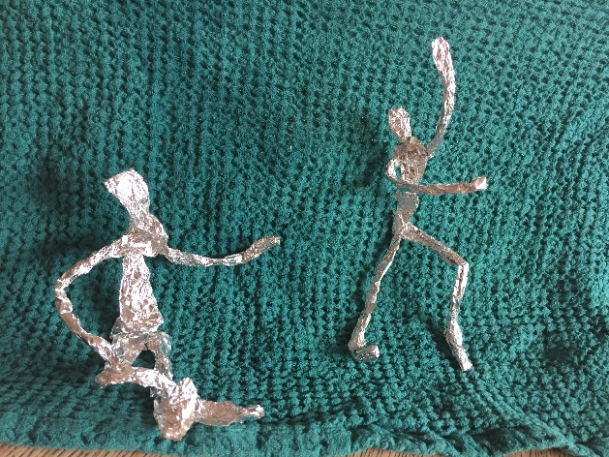
Here are some that I made earlier!
I think my second figure worked out much better than the first, but I enjoyed twisting and moving the foil and placing the figures in different positions. It makes me think of two people chatting, one person who likes to sit and relax and the other who loves to continuously move, fidget and exercise.

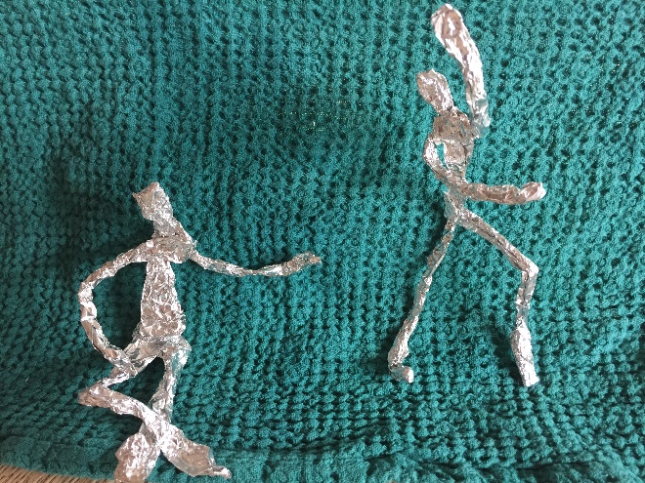
Play and explore and see what figures you can sculpt. Post a photograph of your work for me to see on J2E (zap8)

