Tectonic plate activity
Using the words at the bottom of the page, fill in the table describing some features of tectonic movement.
Type of Margin | Divergent | Convergent | Lateral sliding
Diagram: | 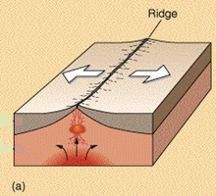 | 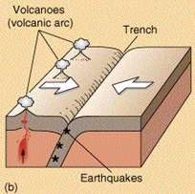 | 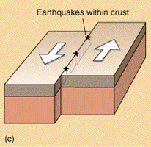
Motion
Effect
Structure created
Volcanic activity?

Words: Ridge/Rift No Destructive (rock destroyed) Subduction Yes Lateral sliding Constructive (rock formed) Trench None Conservative (rock neither formed or destroyed) Spreading Yes

