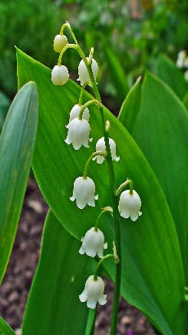
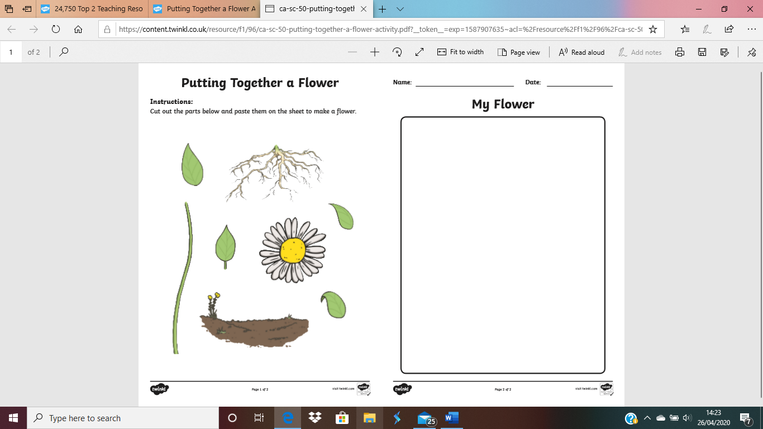
This Photo by Unknown Author is licensed under CC BY-SA

leaf | petal |  | roots
stem | pollen |  | flower
I attract birds and insects like bees.

I collect light to make energy for the plant

I help to move water around the plant

I get water from the soil.

