Investigate these fun facts about the proportions of your body:

- Your foot is the same length as the space between your wrist and elbow.
- When you stand with your arms outstretched like a cross the distance from end to end is equal to the height of your body.
- The size of an adult body is usually 7-7.5 times the size of the head, however artists often aim for 8 times the size when drawing and painting.

Look in the mirror:
pay attention to where your hands reach to when stood with your arms by your side.
How far down your legs are your knees? Do your elbows line up with your waist?

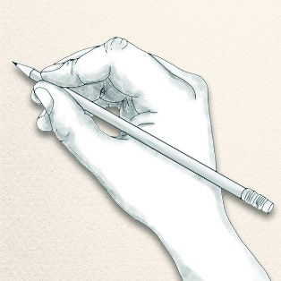
Next, I want you to have a go at sketching some human forms in proportion. Use these resources to help. You do not have to worry about details like faces and clothes and it does not have to be a perfect sketch. Just try to focus on sizes and proportions as next week we are going to use this knowledge to make some simple sculptures. If you want to share your sketches with me on J2E its zap8.

https://www.youtube.com/watch?v=85A_F7_N3t0


