Art Challenge
Some of you might have seen the art challenge from the Getty museum that went viral on the internet recently.
The challenge was to recreate a piece of Artwork that you liked in any way you wanted to. For example:

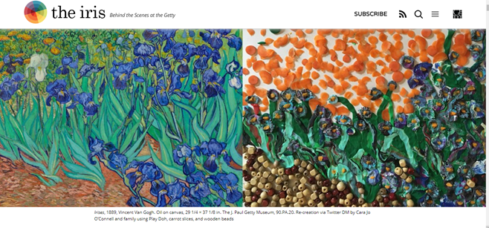
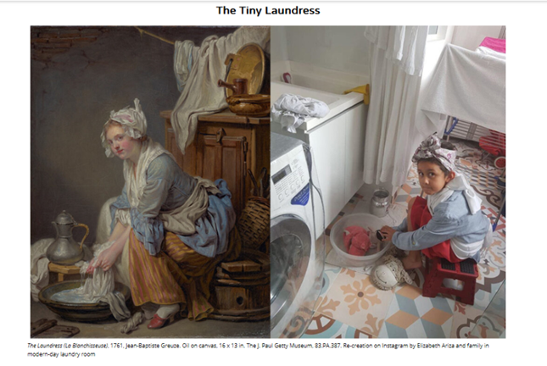
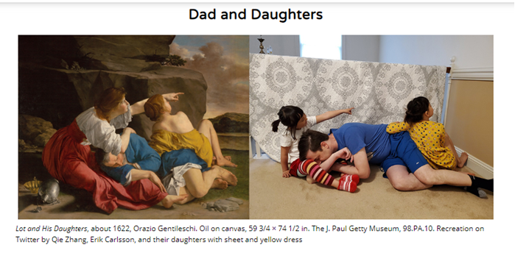
There is a link to the website below where you can see some other fabulous examples and tips.
http://blogs.getty.edu/iris/getty-artworks-recreated-with-household-items-by-creative-geniuses-the-world-over/
I had a go myself along with some friends:
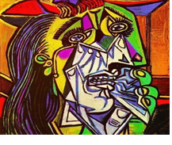
I was challenged to recreate this: The Weeping Woman by Picasso!
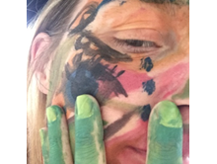

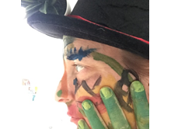
We would like you to have a go at home. Like the images above you can be in the picture on your own or with others in your family or you can use household objects, food, craft items, natural materials from the garden, toys, pets…whatever you can think of its all part of the creativity!
Please post a picture of your masterpieces on J2E and remember to share with Mrs Postlethwaite (zap8)

