How to make a pop-up chick Easter card.
You will need:
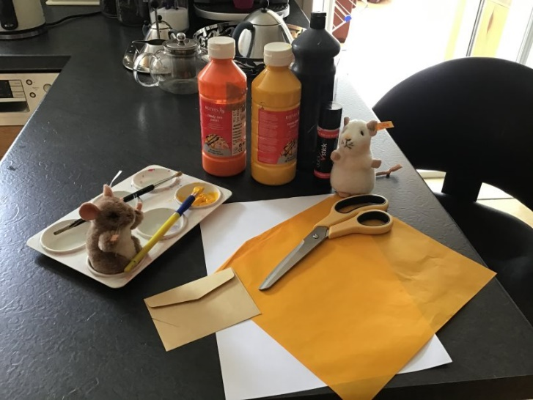
- A piece of white card or thick white paper.
- Yellow, red or orange and black paint
- Yellow tissue paper or feathers
- An old envelope
- Scissors
- A glue stick
- Colour pens or pencils

What to do:
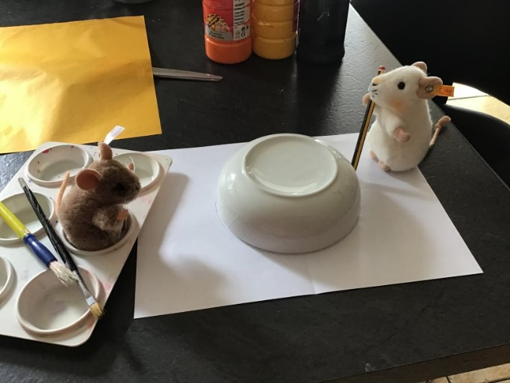
- First fold your paper in half and draw round a plate or bowl so you have a circle in the middle of your card.

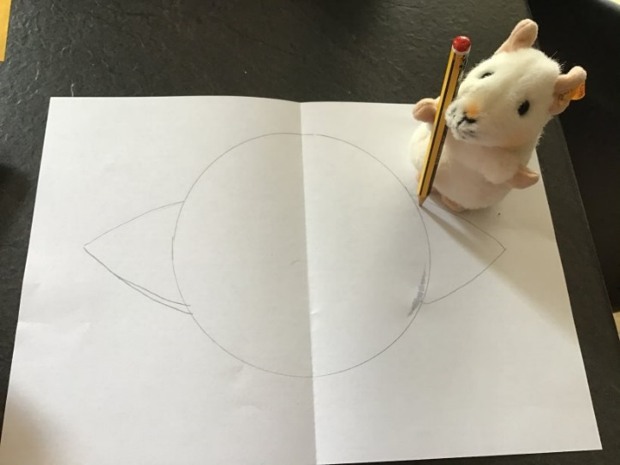
- Next draw some wings on either side of your circle (this will be your chick’s body).

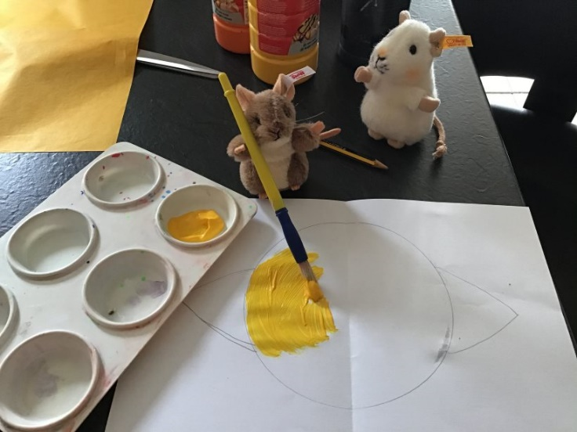
- Paint your chick yellow (Mickey Thompson is very fond of painting).

- After that cut up your tissue paper or feathers into small pieces and stick them on the yellow paint to make your chick nice and fluffy (Purvis likes to be in charge of the scissors).
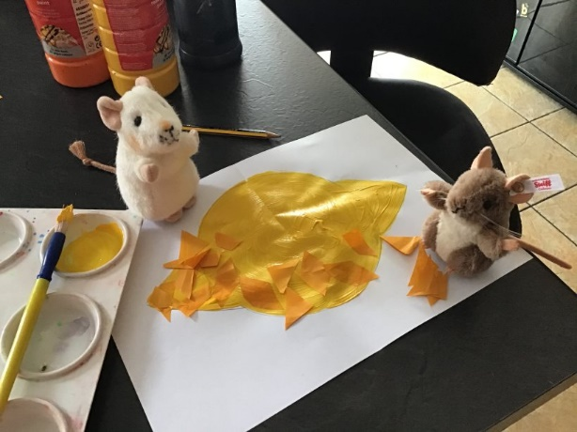
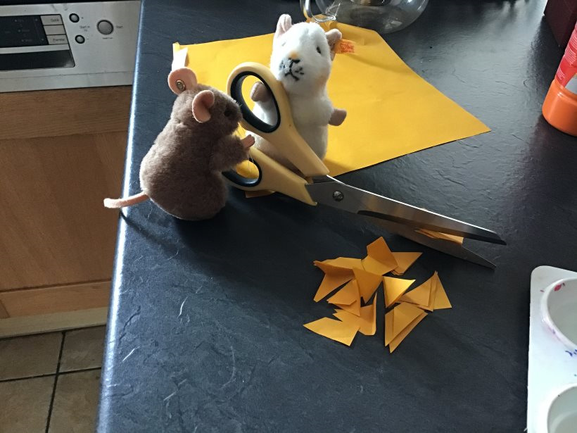
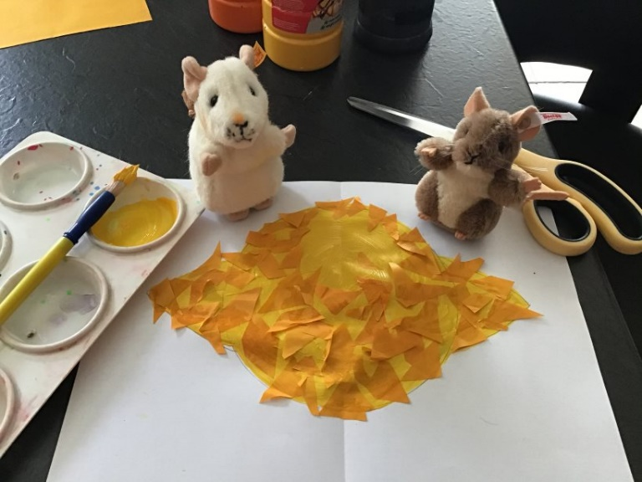

- Next cut the corner off an old envelope and flatten it out so it makes a beak shape.

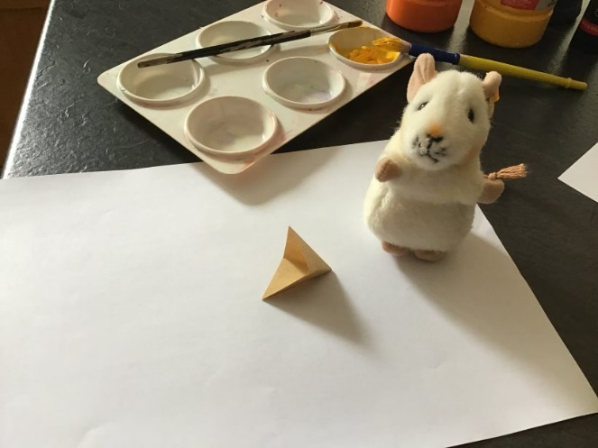
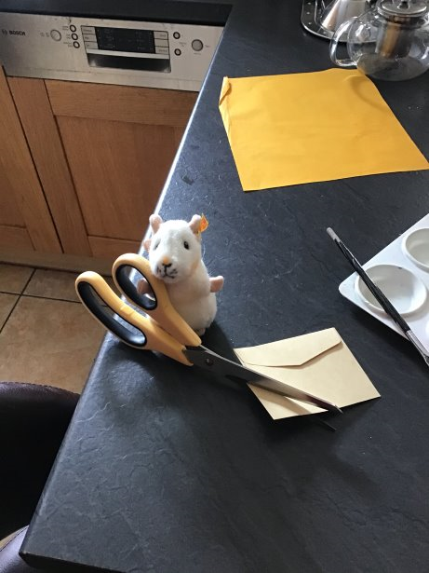

- Then paint the beak red or orange inside and out.
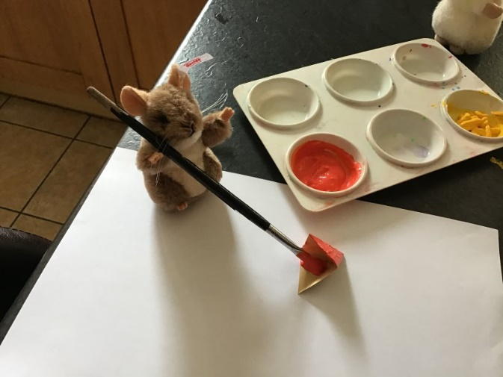

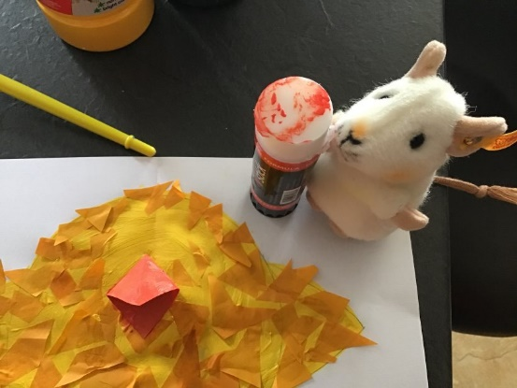
- Stick your beak on your chick along the fold in the paper.

- Next use your paints to add legs and eyes to your chick.
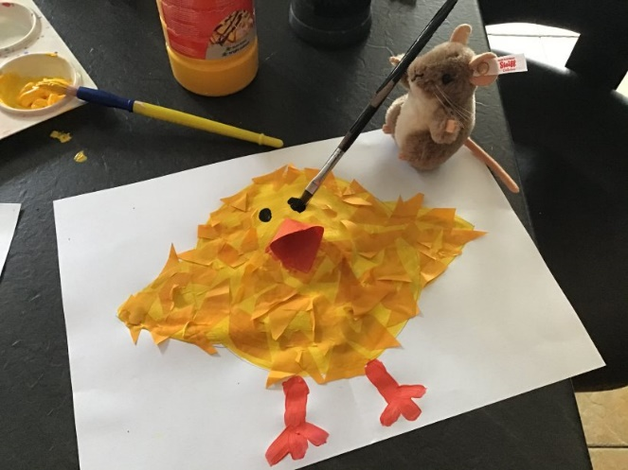

- Finally use your colour pens or pencils to add some extra decoration and write Happy Easter on your card (Mickey Thompson did the decorating and Purvis did the writing).
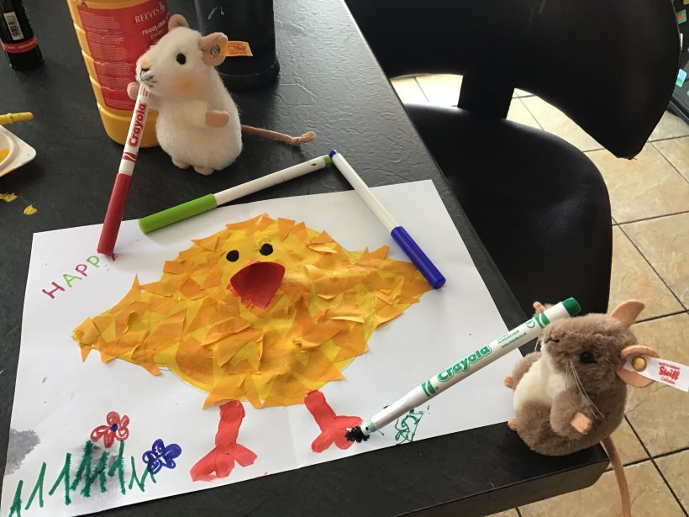

Your card is now finished and you can send it to someone you love for Easter. It might be nice to send it to someone you won’t see for a while. Purvis and Mickey Thompson are going to send their card to Uncle Gillian.

