Habitats
I want you to watch:
https://www.youtube.com/watch?v=ZrSWYE37MJs
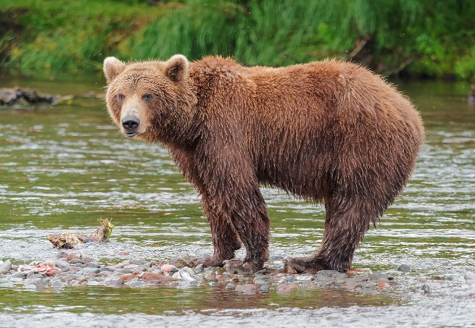
Stop at 2mins 56: How are they different?
Compare the characteristics of the bears.
what is their fur like, why might they have different coloured fur?
In what kind of habitat would you find these bears?
Why do you think we wouldn’t find a bear in a desert?
Now watch the video to the end.
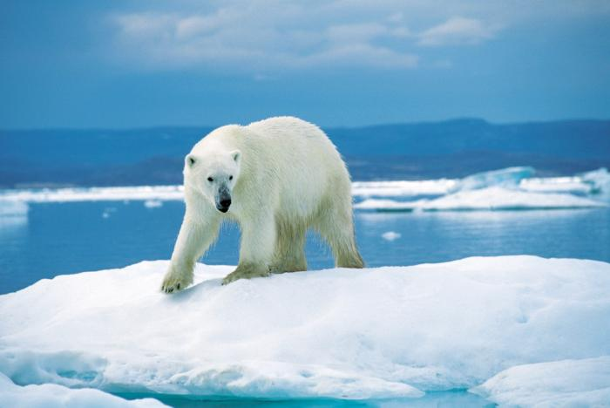
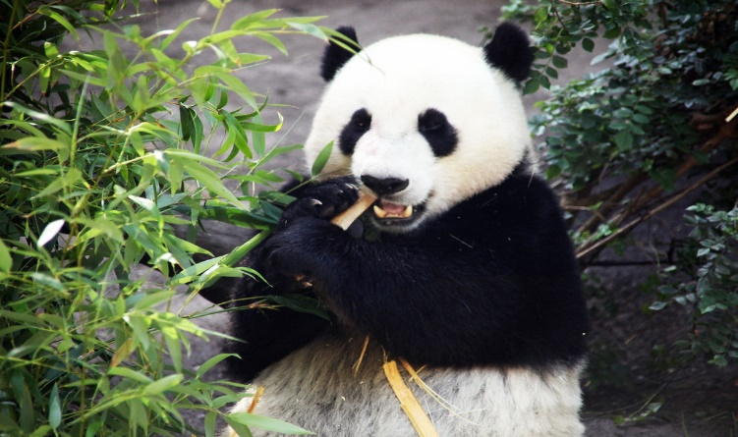

Next choose a habitat that most interests you from the following:
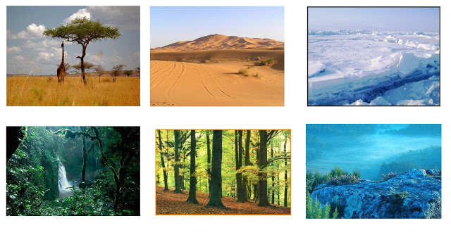
Forest (temperate or tropical)
Oceans
Rivers
Desert
Mountains
Grasslands/savannah
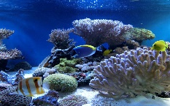
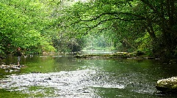
Arctic regions
This Photo by Unknown Author is licensed under CC BY-NC-ND
This Photo by Unknown Author is licensed under CC BY-SA

I would like you to investigate your chosen habitat and find out how some of the creatures that live there have adapted to their habitat. Choose at least 3.
You can use books/the internet and family knowledge. These sites have lots of useful resources and lots of related videos on YouTube:

Discovery Education
National Geographic kids (Amazing animals)
Blue Planet
BBC Earth
Deadly 60

Think about and investigate similar things to those you saw in the video:
How does the animal’s body suit their habitat? Do they have special characteristics or camouflage?
How do the animals protect themselves from predators or what makes them a successful predator?
What is the diet of the creature?

You can choose how to present your learning in one or more of the following ways:

- Create a fact-file on one of the creatures on the template provided. (See below p3)
- Create a video clip on a phone/PC/ tablet in the style of a nature documentary telling people about your chosen 3 animals and their habitat.
- Create a large picture of the habitat you are investigating then add your chosen animals and some lift the flap facts.

Try your best to include facts and interesting words and if you are recording a video think about using props like toys.

Habitat and Animal Fact File

Name:___________________________Habitat:_________________________
Animal (mammal/bird/amphibian/reptile/fish): ______________________________
Picture or photo
Interesting Facts
___________________________________________________________________________________________________________________________________________________________________________________________________________________________________________________
Is this creature a:
Carnivore
Herbivore
Omnivore
How the creature adapts to its environment:
______________________________________________________________________________________________________________________________________________________________________________________________________________________________________________________

