History – Week 1
Who was this significant person?
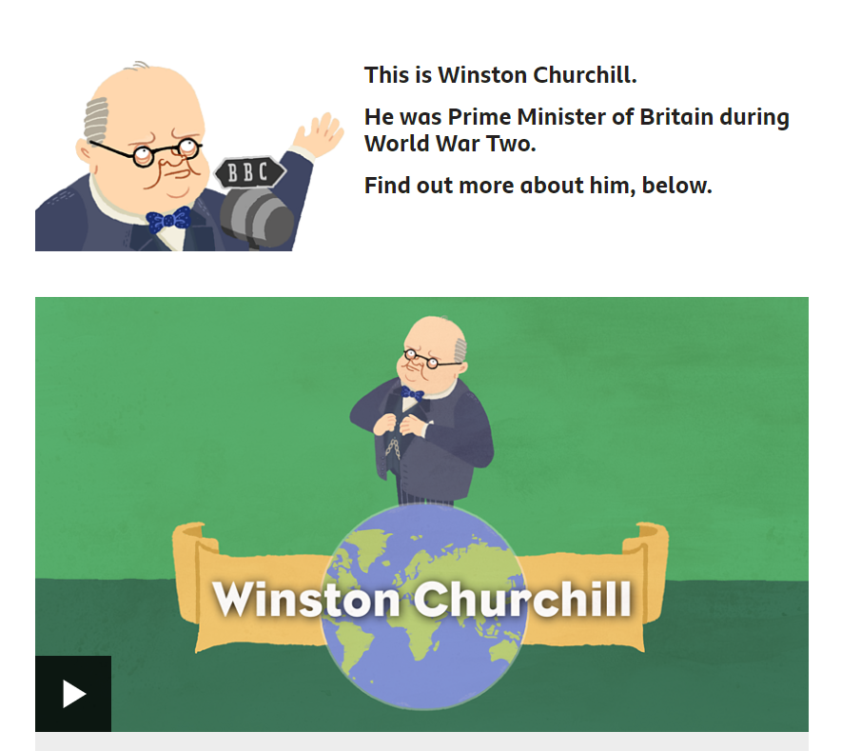
Click here to find out more about Winston Churchill https://www.bbc.co.uk/bitesize/topics/zkrkscw/articles/zfq9pg8
Complete the online activities.

Extra challenge …. Winston Churchill liked painting. Can you paint a portrait of him?

