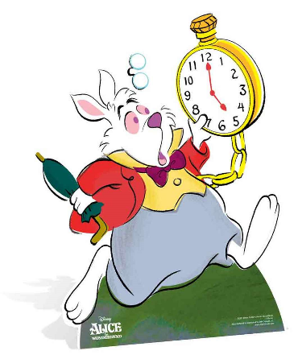
Reception and Year 1.
Just a minute!
Do you know how long a minute is?
Warm up - Sit on the floor and ask a grown up to time you. When you think a minute has passed stand up.
How close were you?
Activity – Reception and Year 1.
What can you do in a minute?
Look at the table attached. Estimate how many times you can do each thing in a minute and write the number in the first box.
Then ask a grown up to time you and see what the actual number is.
Were you close?
Maybe you can challenge some of your family members to have a go to. I have left some boxes blank at the bottom so you can fill in your own activities.
Year 1 problem solving challenges.
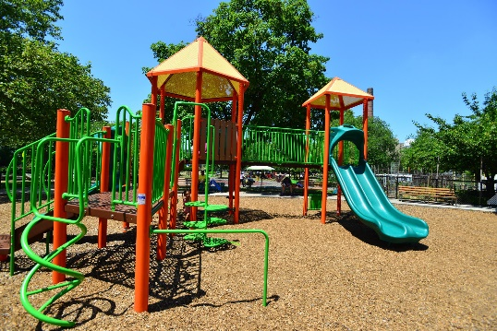
On Saturday, I played at the park for 15 minutes. On Sunday, I played for longer. Can you write an amount of time I could have played for? Explain how you know it is correct.

•Mick, Seb and Annie all walk to a football match.

Mick takes 8 minutes to walk there.
Seb is 3 minutes slower than Mick.
Annie is 5 minutes faster than Seb.
Who arrived at the football match first?

