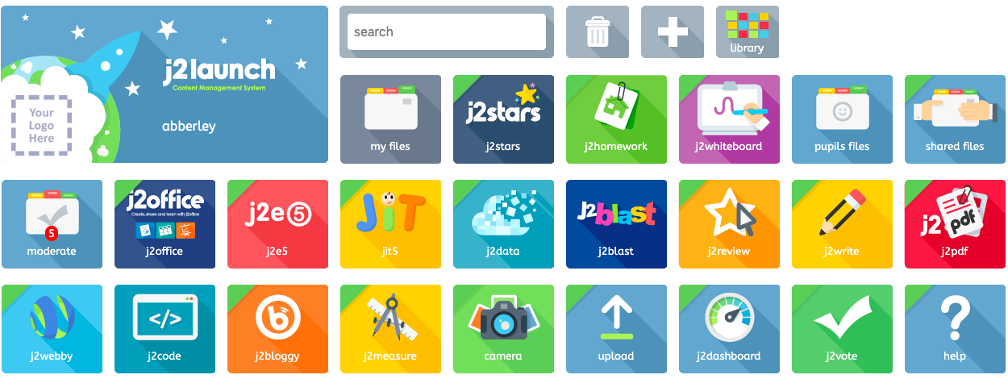

Click ‘J2BLAST’
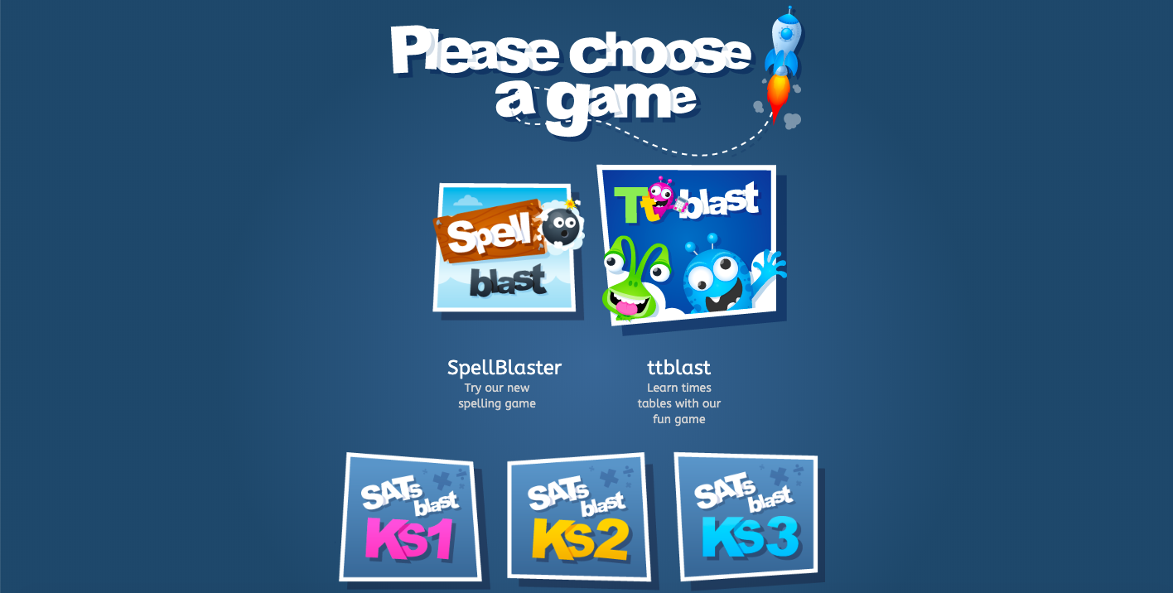

CHOOSE ‘SPELL BLAST’

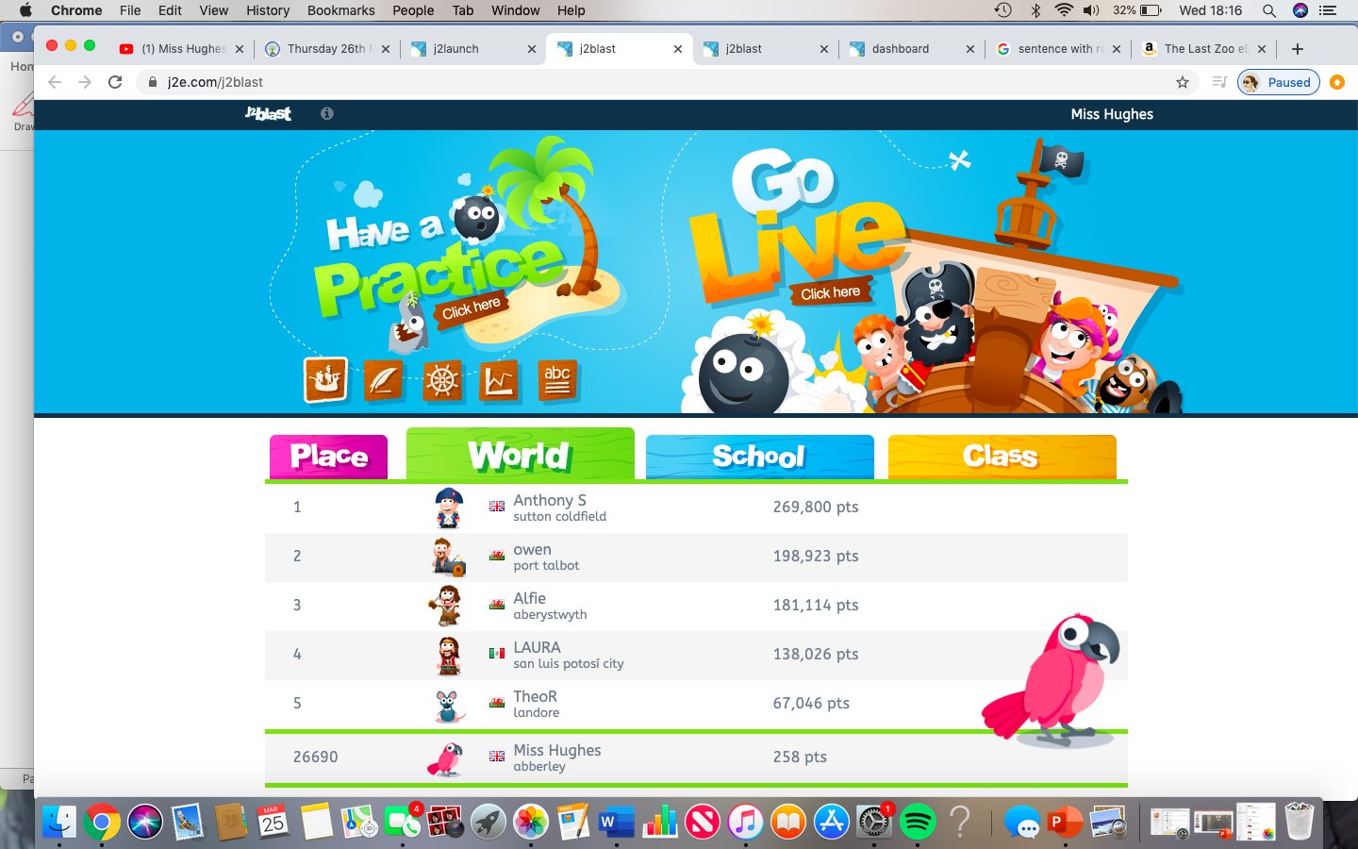

Under
‘Have a practice’
select-
‘CLICK HERE’

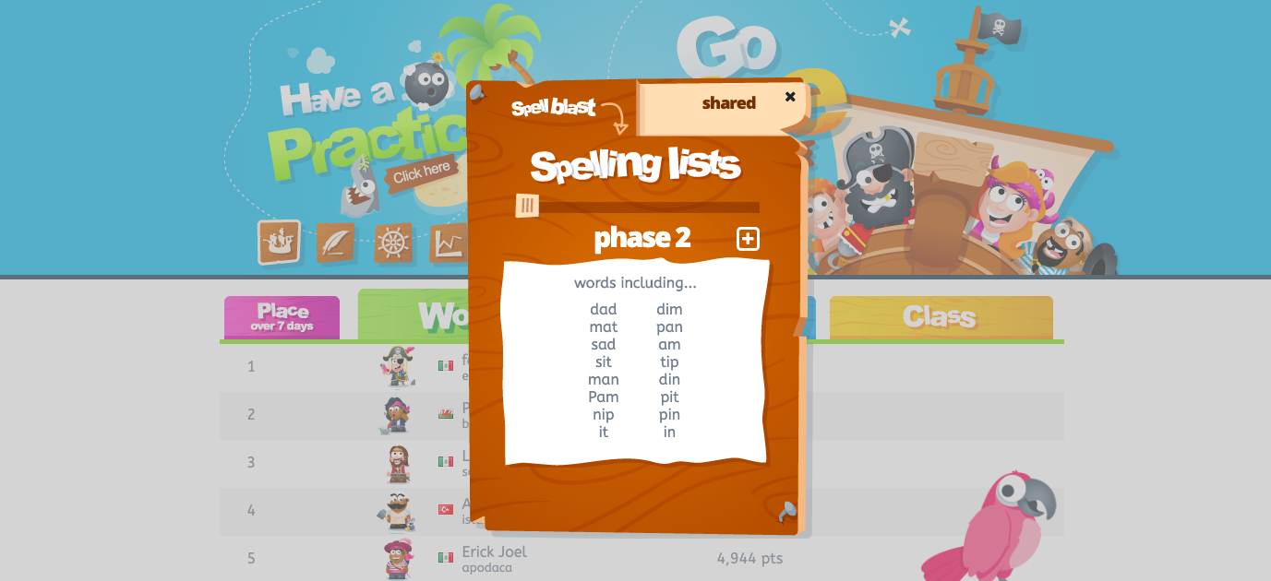
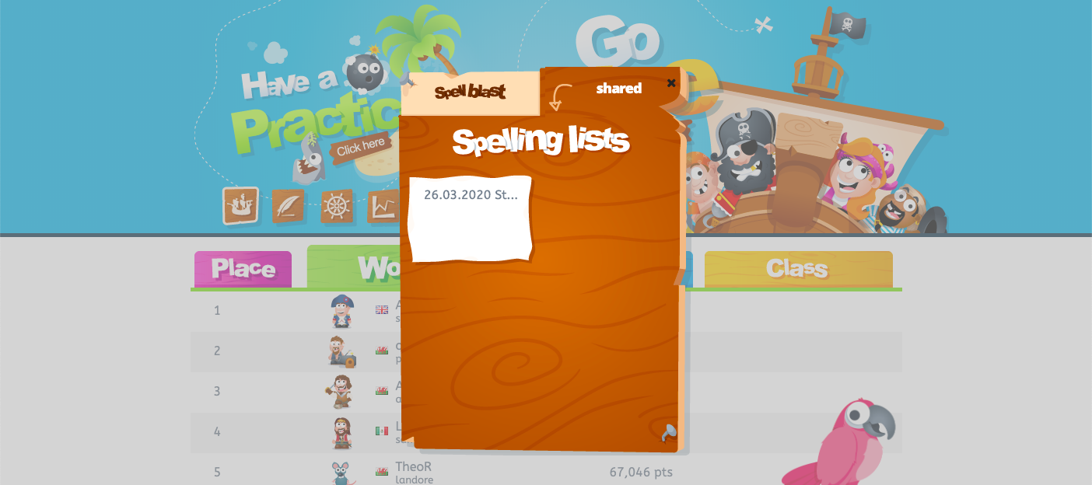

Select the list labelled with today’s date.

Go to the
‘shared’ section.

