
1. What is special about Jo, Raja and Sammy?

2. The story talks about Raja’s family. Who is in her family?



3. Describe what you think Jo’s house is like.

4. A park is the setting for the story. Can you describe this setting?

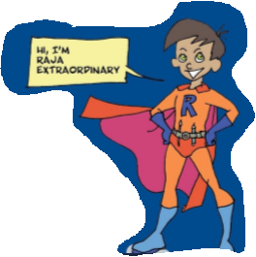
5. How do you think the crowd at the bottom of the climbing frame felt when the child had been rescued?

6. Would you like to be a superhero? Why?

