Reception and Year 1.
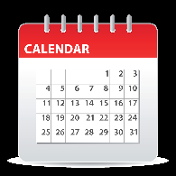
Cut out the time words below and decide whether they are associated with measuring “long” periods of time on a calendar

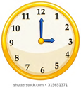
or “short” period of time on a clock.

Stick them in the appropriate place on the chart.
Can you add some examples of things you might measure using a calendar or a clock?
e.g. calendar – birthdays, summer holidays.
clock – the length of a tv programme, bedtime.
Reception only - have a look round your house. What things can find for measuring time?
Year 1 only – have a go at filling in the gaps in the sentences below with the correct numbers.

Day
Month

Second
Minute
Year

Week
Hour

Season
Calendar  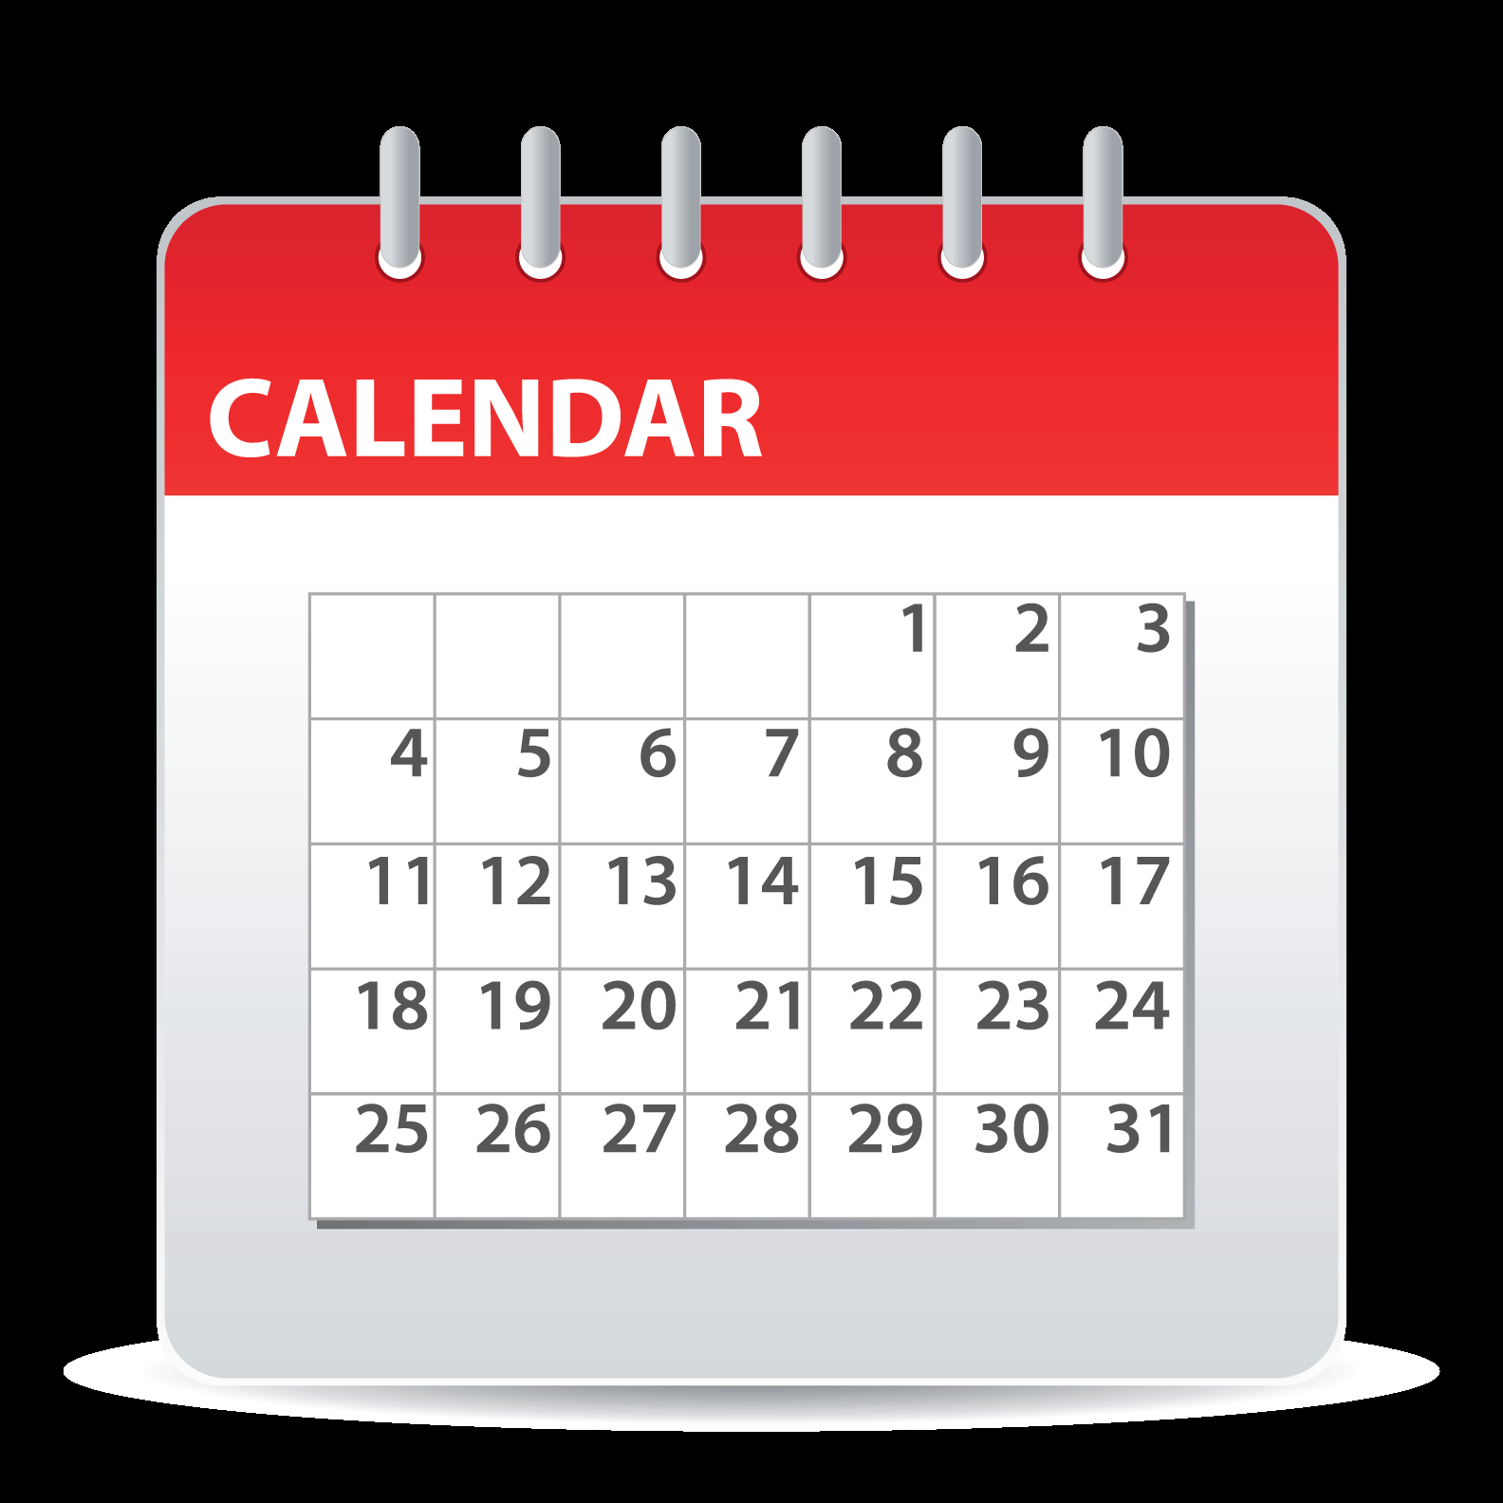 | 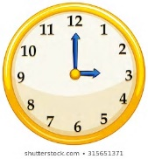  Clock
Select the correct number from the box to complete the sentences.

There are seasons in a year.
4
60
60
7
30
365
12
24
31

A year has months.

There are days in a year.

Most months have or days.

A week has days.

There are hours in a day.

An hour has minutes and a minute has seconds.

