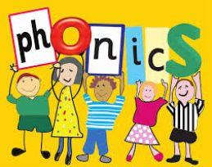
Monday 23 March 2020.
Year 1.
Your sound today is the split digraph u-e. Remember this can make the u (cube) or oo (June) sound.
Can you remember the other ways we can make these sounds? ue and ew
How many words can you think of that contain the u-e split digraph?
Have a go at the u-e phoneme spotter story attached. How many words can you highlight with the u-e sound?
Write a postcard back from June to Luke. How many u-e words can you include?
The website www.phonicsplay.co.uk, is allowing temporary free access to parents. It has lots of great games and activities for your child. Year 1 children are currently working on phase 5 phonics.

