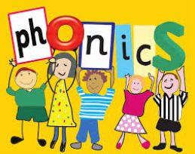

Monday 23 March 2020.
Reception.
Your sound today is th. This makes either a soft sound as in bath or a hard sound as in weather.
Copy and paste the link below to Mr Thorne on youtube to practise saying the sound. https://www.youtube.com/watch?v=6hZMjZGNq4g
What words can you think of with the th sound in? Remember it can come at the end of words (maths, path, moth) or it can appear in tricky words (the, they, there).
Have a go at writing a caption for this picture

thick and thin pens

On the website www.phonicsplay.co.uk, click on free phonicsplay. Click on the purple phase 3 tab on the left hand side and scroll down until you find Buried Treasure. Select phase 3 (purple tab) and then +th. Your child will know how to play the game!
It looks as though this website is allowing temporary free access to parents. There are lots of great games and activities for your child. Your child is currently working on phase 3 phonics.

